**Group members:**

**Akbar Turdiev 00014826**

**Shamsiddin Ergashev 00014648**

**Zulfiyaxon G’afurova 00017232**

**Robiya Zoirova 00015967**

**Malika Jalilova 00014353**

**Little Italy**

1. **Choose your language!/Выберите язык!**

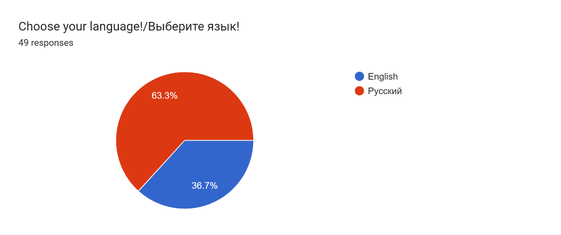

1. **What is your gender?  
   Forms response chart. Question title: What is your gender?
   . Number of responses: 18 responses.**

**Forms response chart. Question title: Выберите свой пол
. Number of responses: 31 responses.**

1. **Indicate your age!**

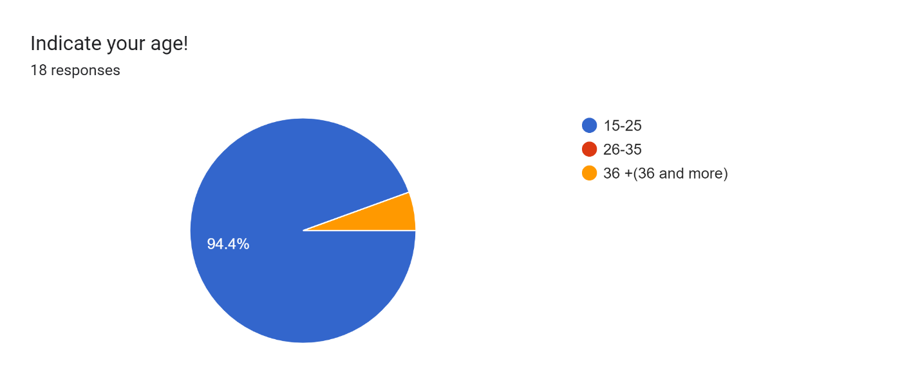

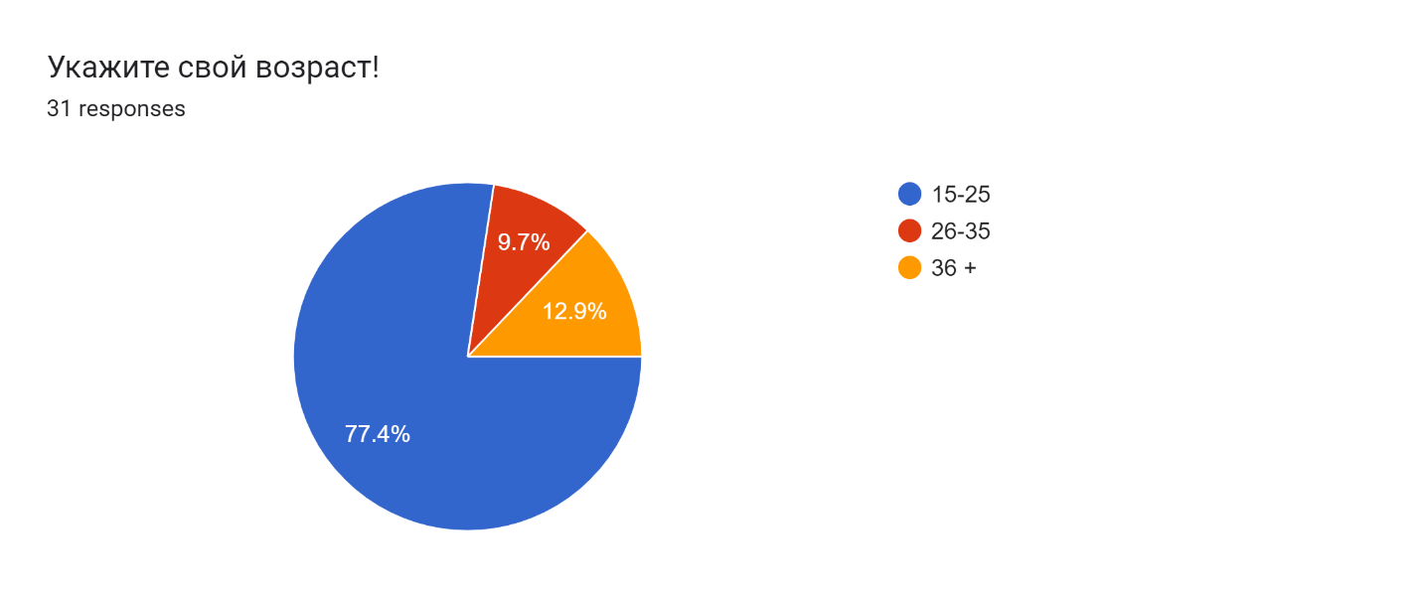

1. **Do you like dine out?**

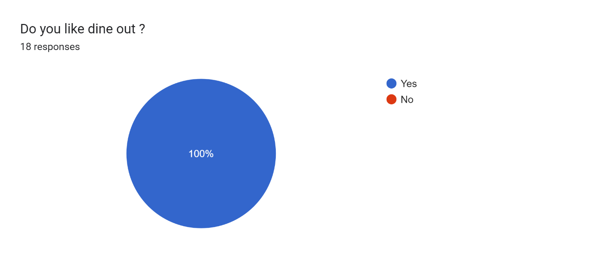

**Forms response chart. Question title: Вам нравится ужинать в ресторане ? 
. Number of responses: 31 responses.**

1. **Would you rate how often it is?  
   Forms response chart. Question title: Would you rate how often it is?
   . Number of responses: 18 responses.**

**Forms response chart. Question title:  Оцените  как часто это происходит?
. Number of responses: 31 responses.**

1. **Do you like Pizza?**

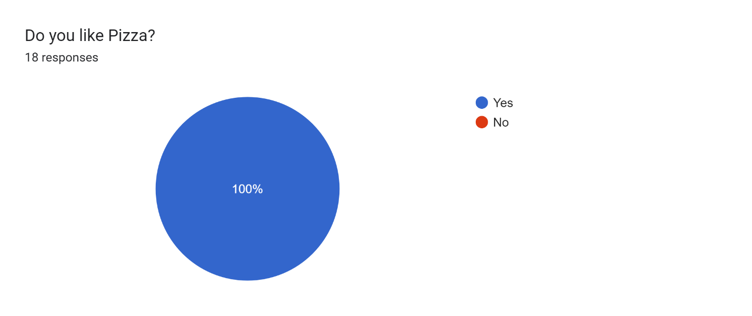

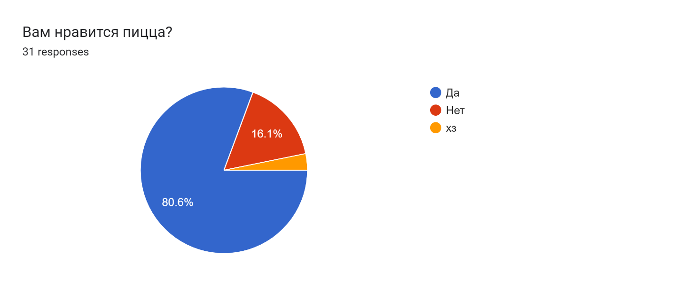

1. **What is your most important criteria of choosing a pizzeria?**

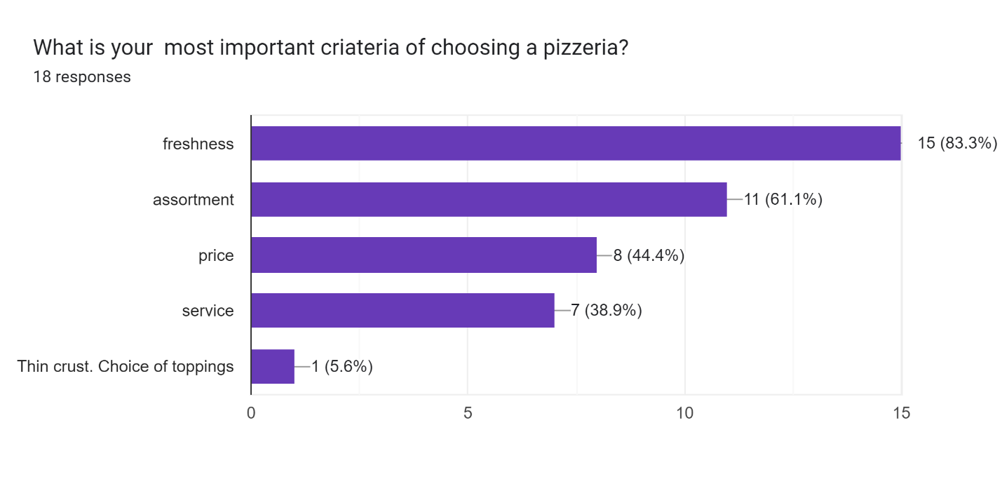

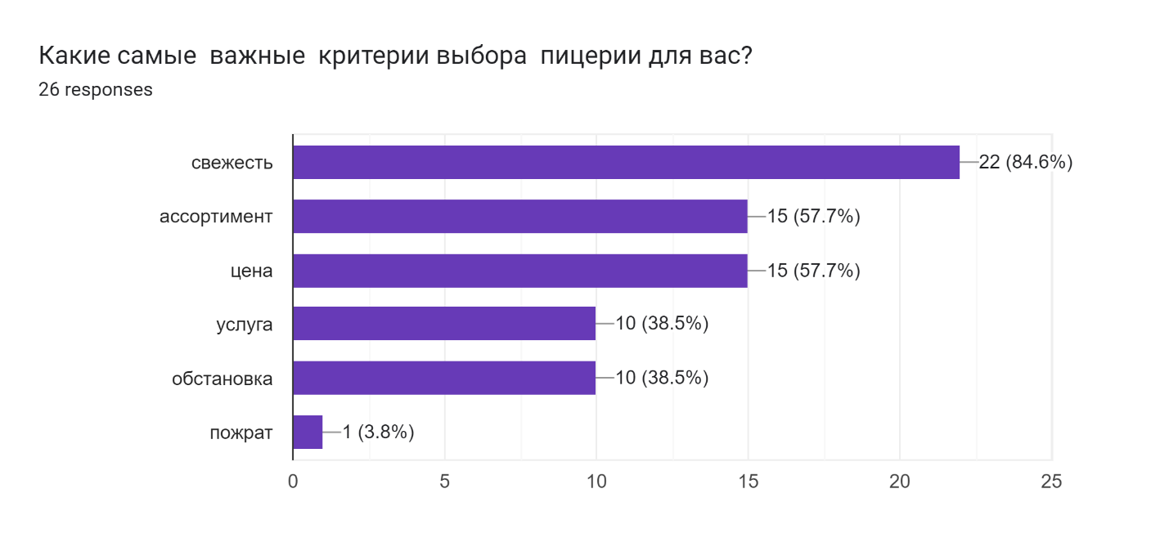

1. **How important delivery services for you?**

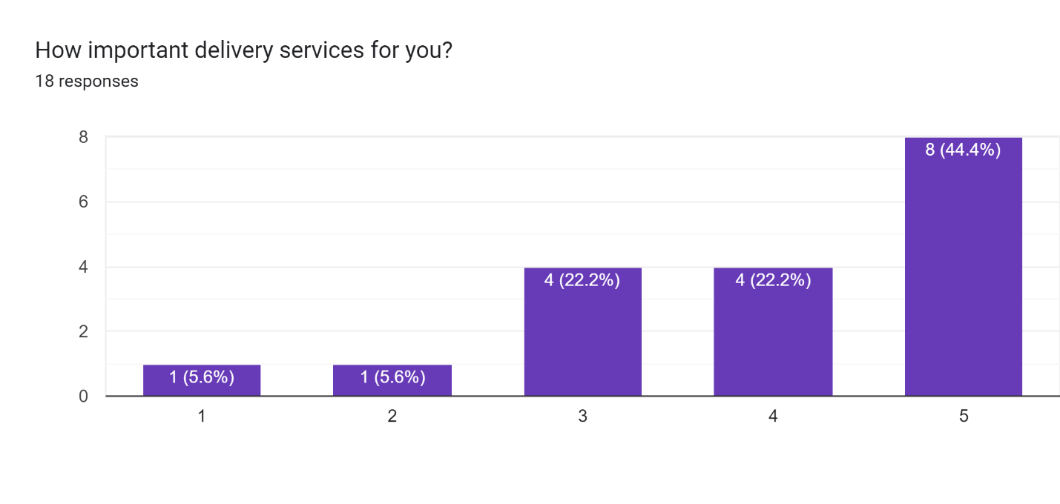

**Forms response chart. Question title: Насколько для вас важен  служба доставки?
. Number of responses: 26 responses.**

1. **How important are restaurant discounts and promotions to you ?**

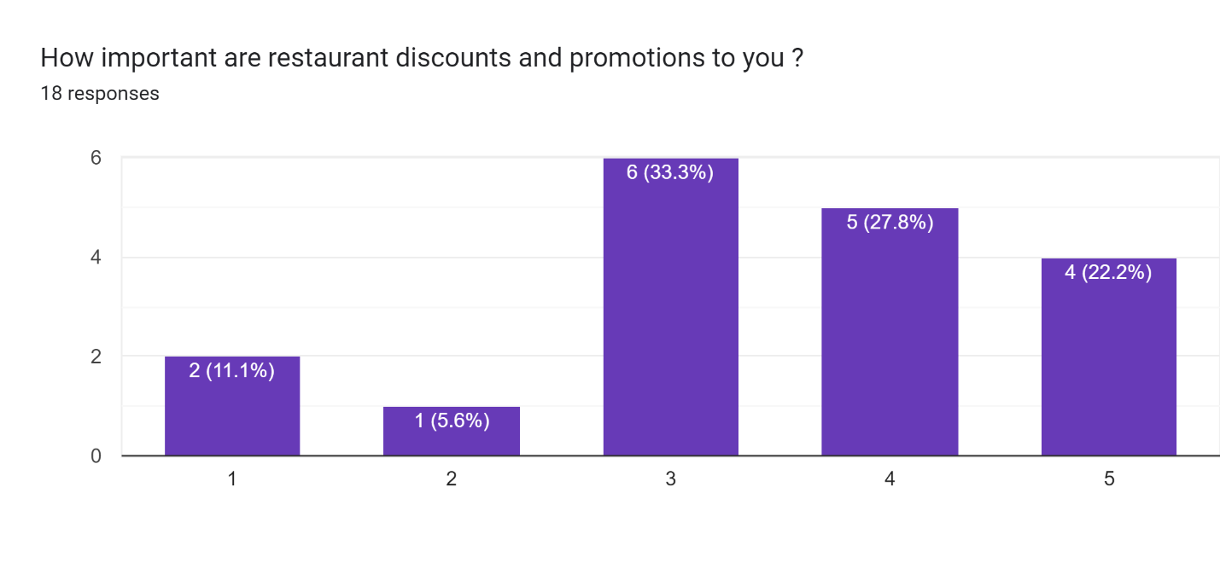

**Forms response chart. Question title: Насколько важны акции в пиццерии?
. Number of responses: 26 responses.**

1. **What time do you prefer to eat Pizza?**

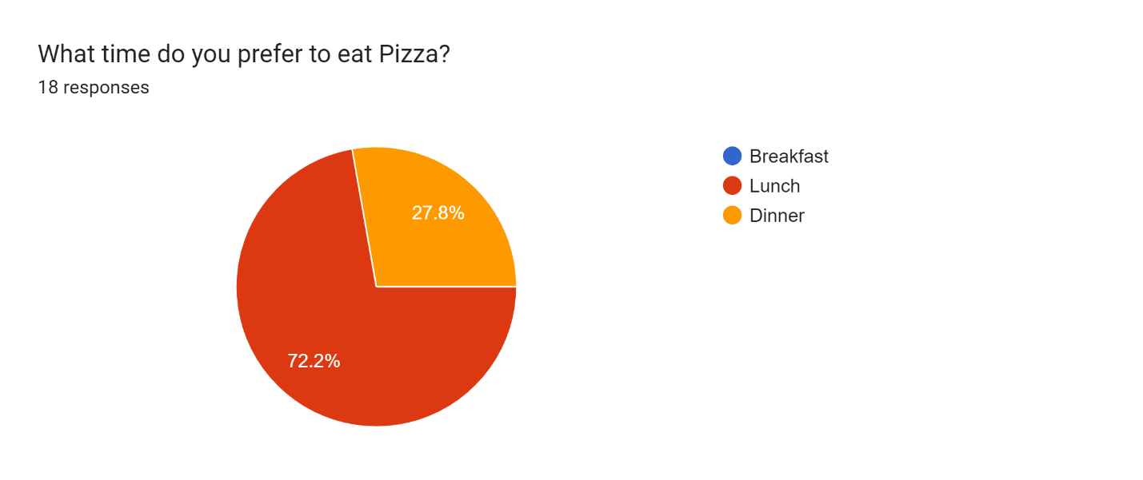

**Forms response chart. Question title: В какое время дня вы предпочитаете есть пиццу
. Number of responses: 26 responses.**

1. **How often you consume pizza?**

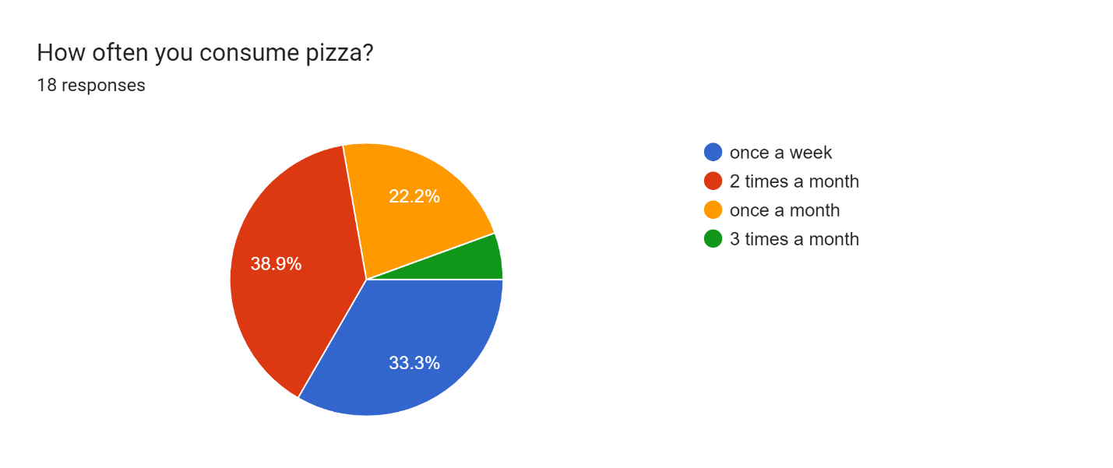

**Forms response chart. Question title: Как часто употребляете пиццу
. Number of responses: 26 responses.**

1. **Where do you choose your pizza?**

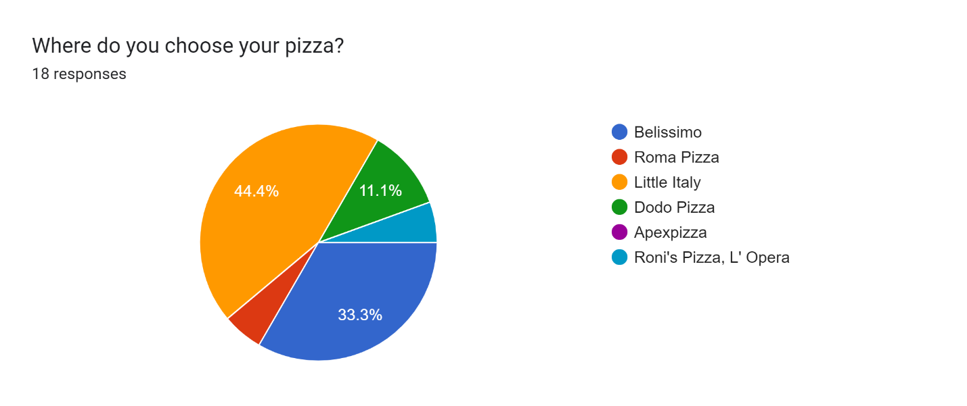

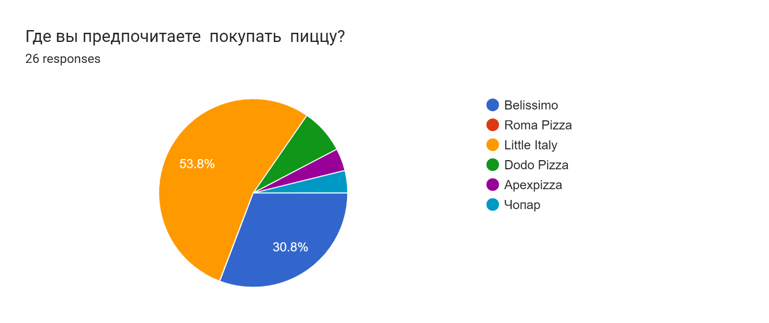

1. **Do you typically get your pizza from the same pizzeria or do you like to taste different?**

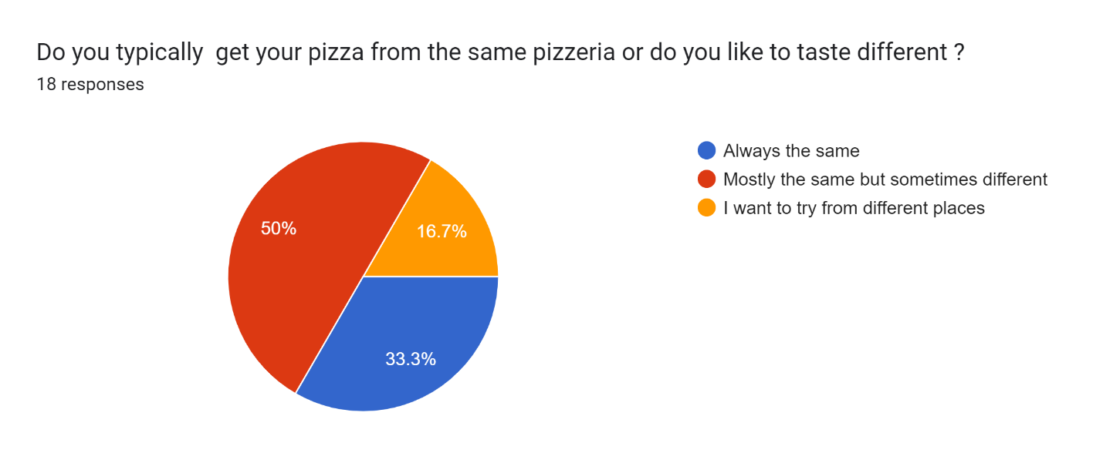

**Forms response chart. Question title: Вы обычно покупаете пиццу в одном месте или предпочитаете пробовать разные?
. Number of responses: 26 responses.**

1. **Which are important options for purchasing in restaurants?**

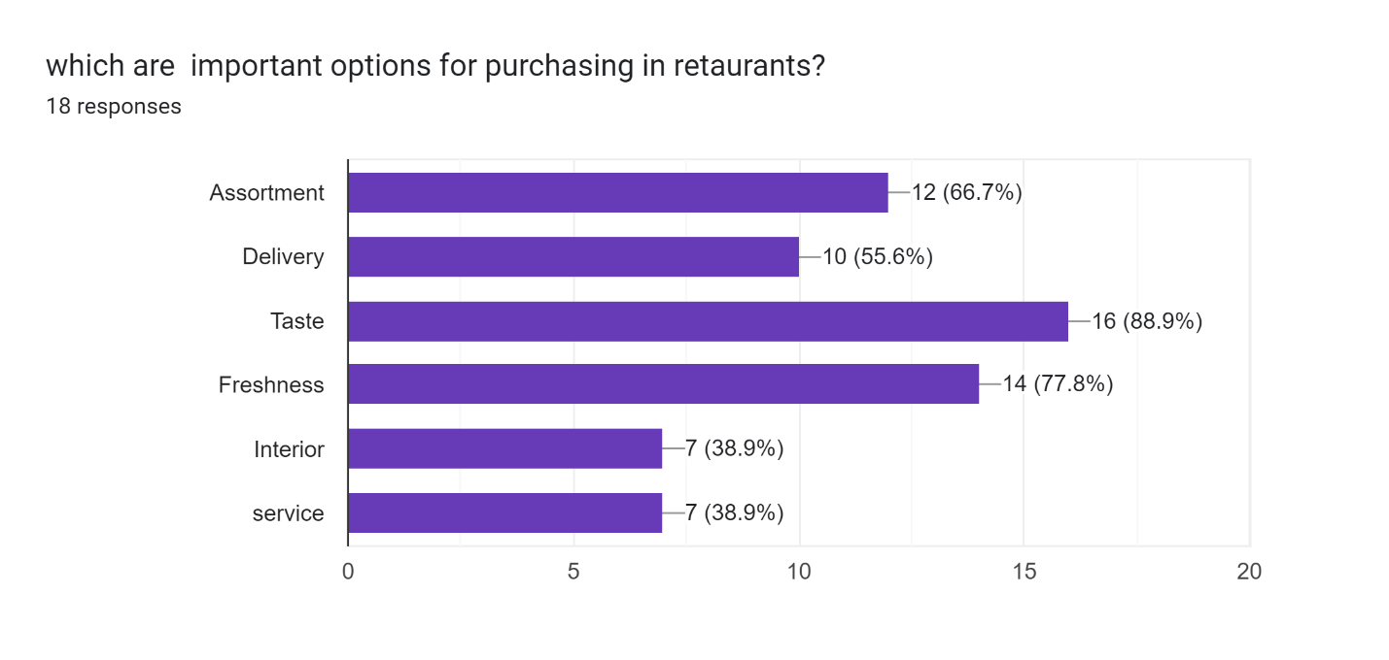

**Forms response chart. Question title: какие важные опции для покупок в пиццерии?
. Number of responses: 26 responses.**

1. **Have you ever heard/been in Belissimo?**

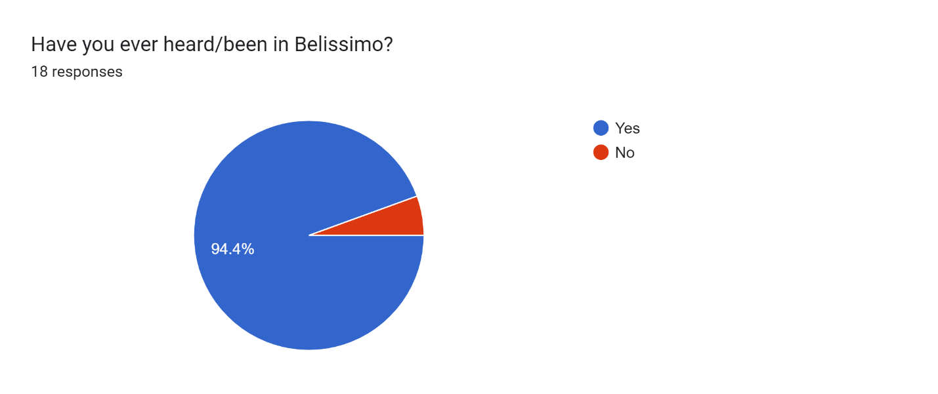

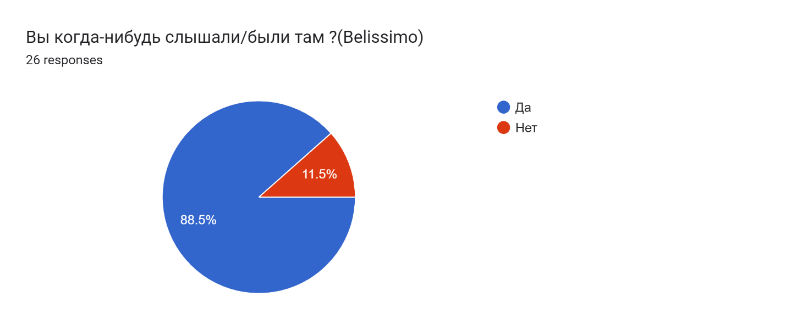

1. **If Yes What did you like about there?**

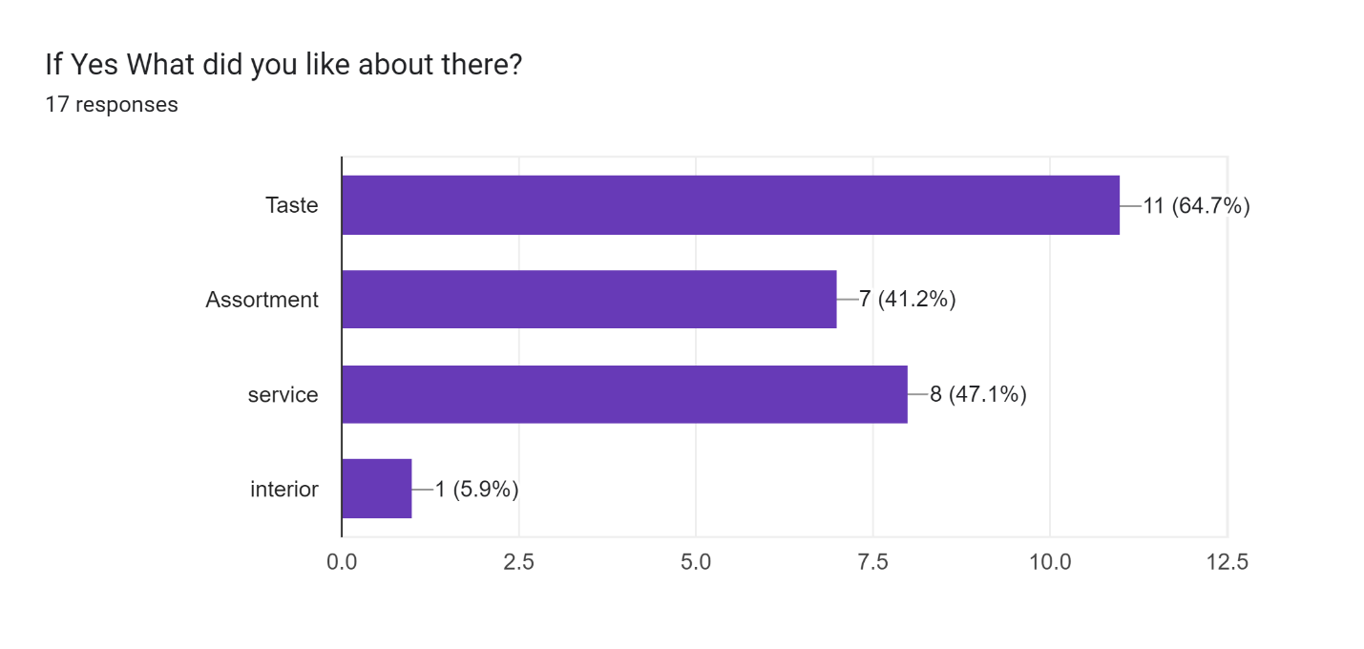

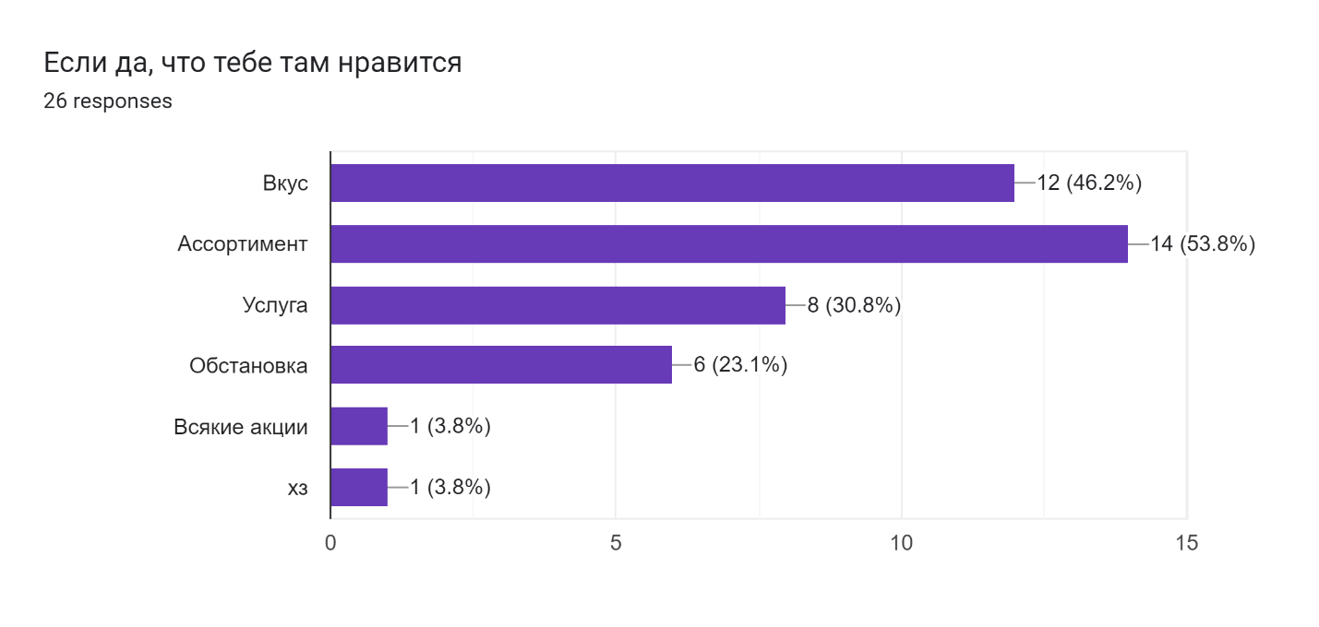

1. **What did you dislike about there? (Belissimo)**

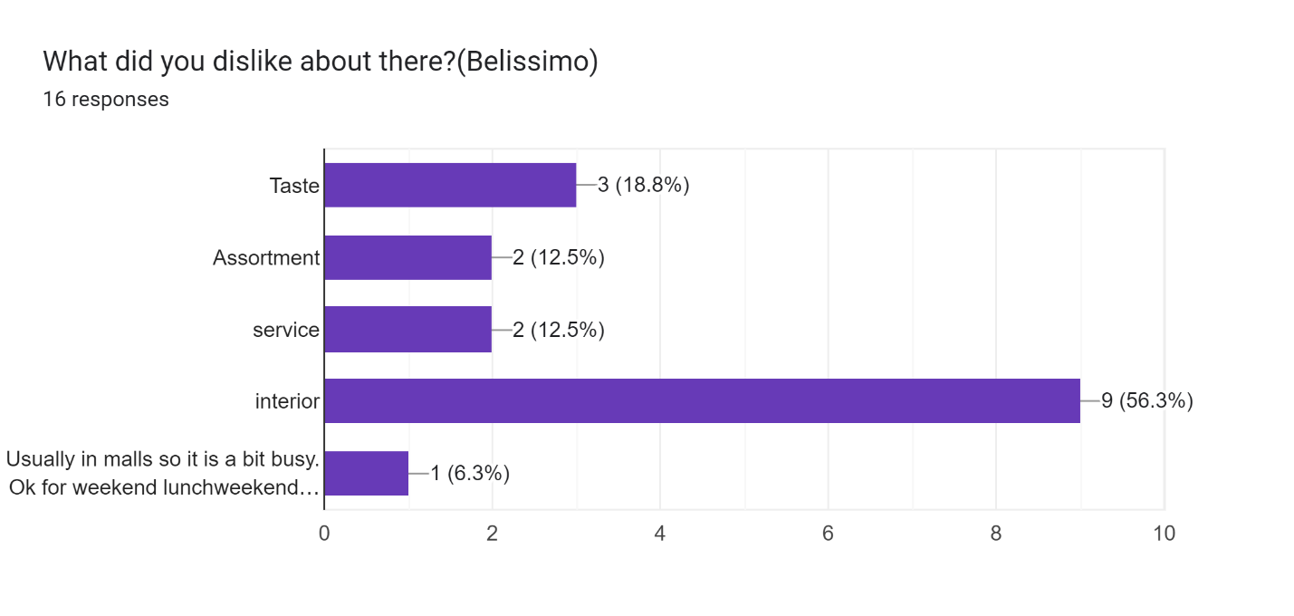

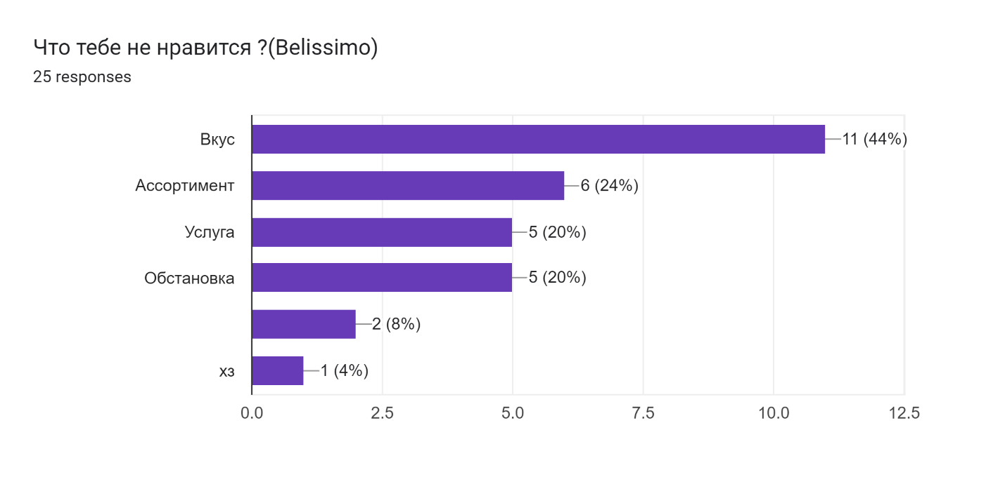

1. **Have you ever heard/been about Apexpizza?**

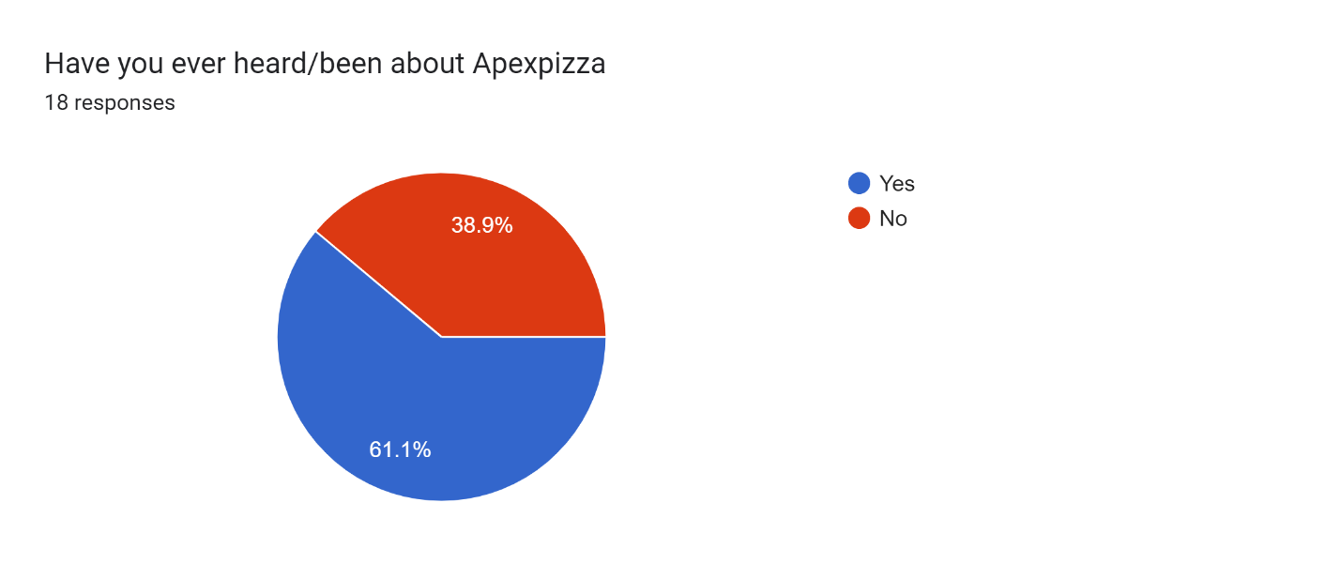

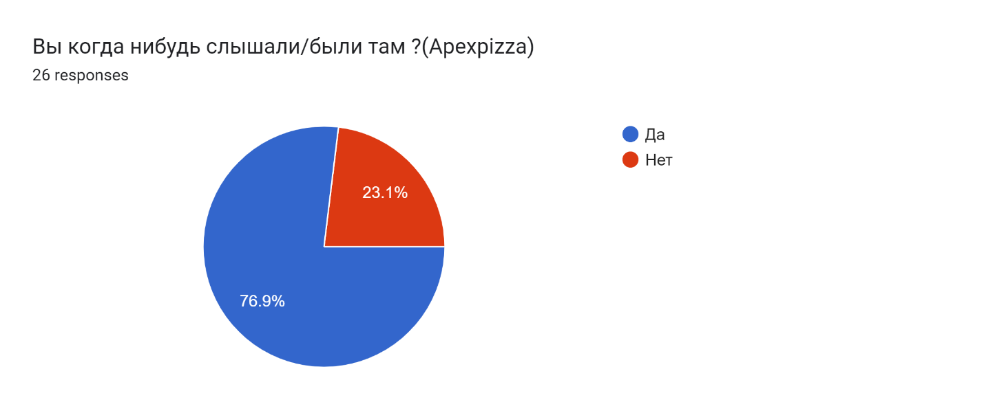

1. **If Yes What did you like about there?**

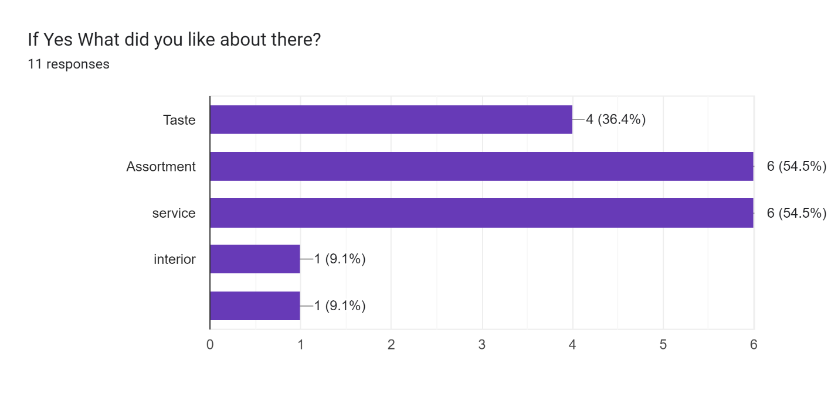

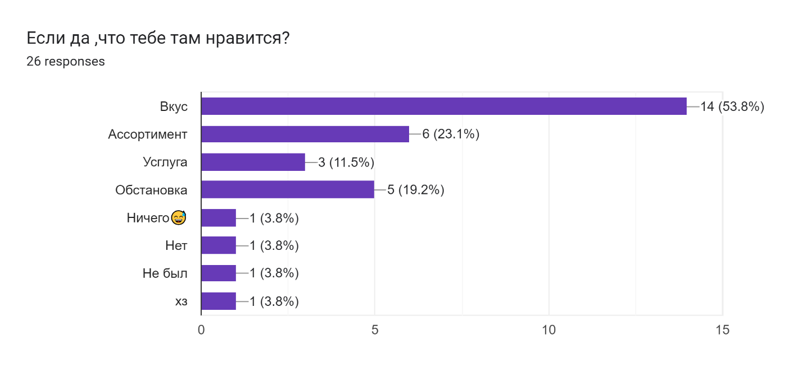

1. **What did you dislike about there? (Apexpizza)**

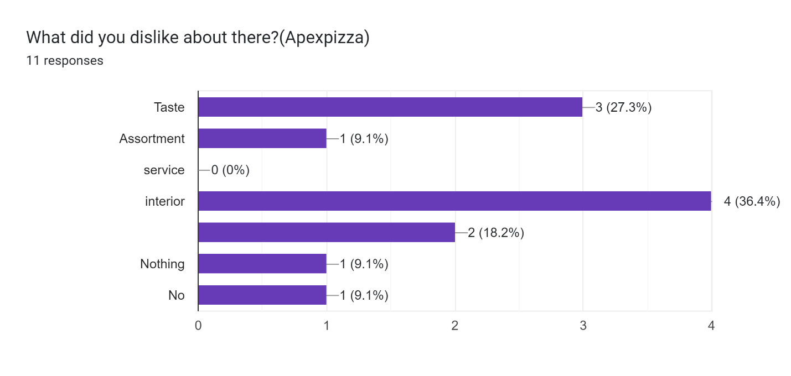

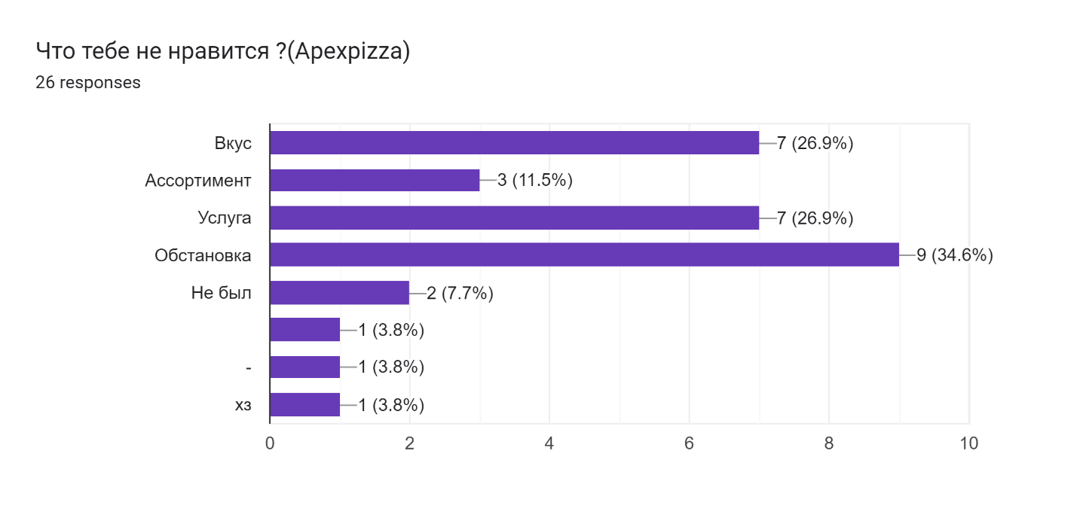

1. **Have you ever heard/been in Roma Pizza?**

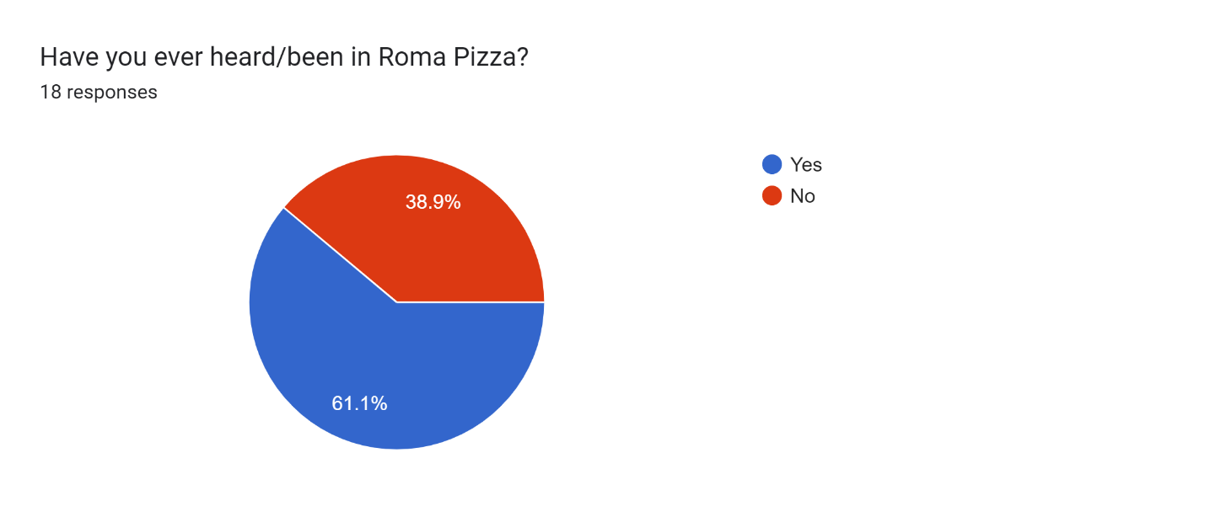

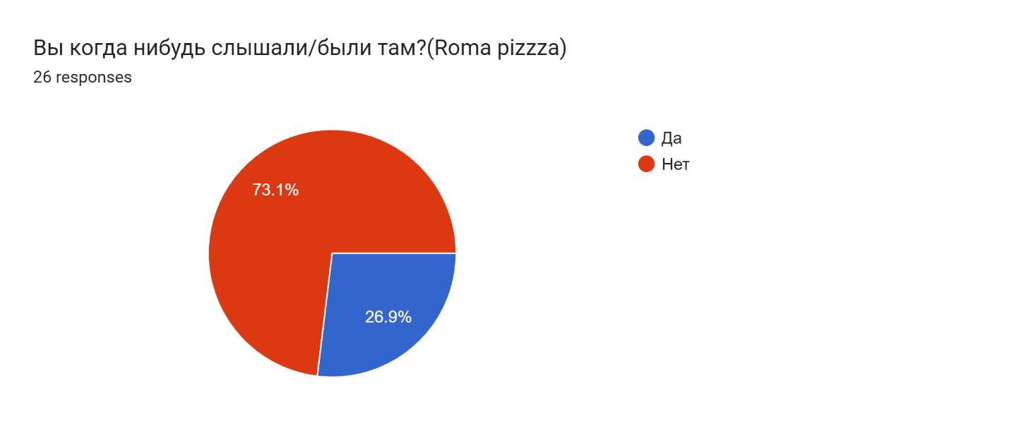

1. **If Yes What did you like about there?**

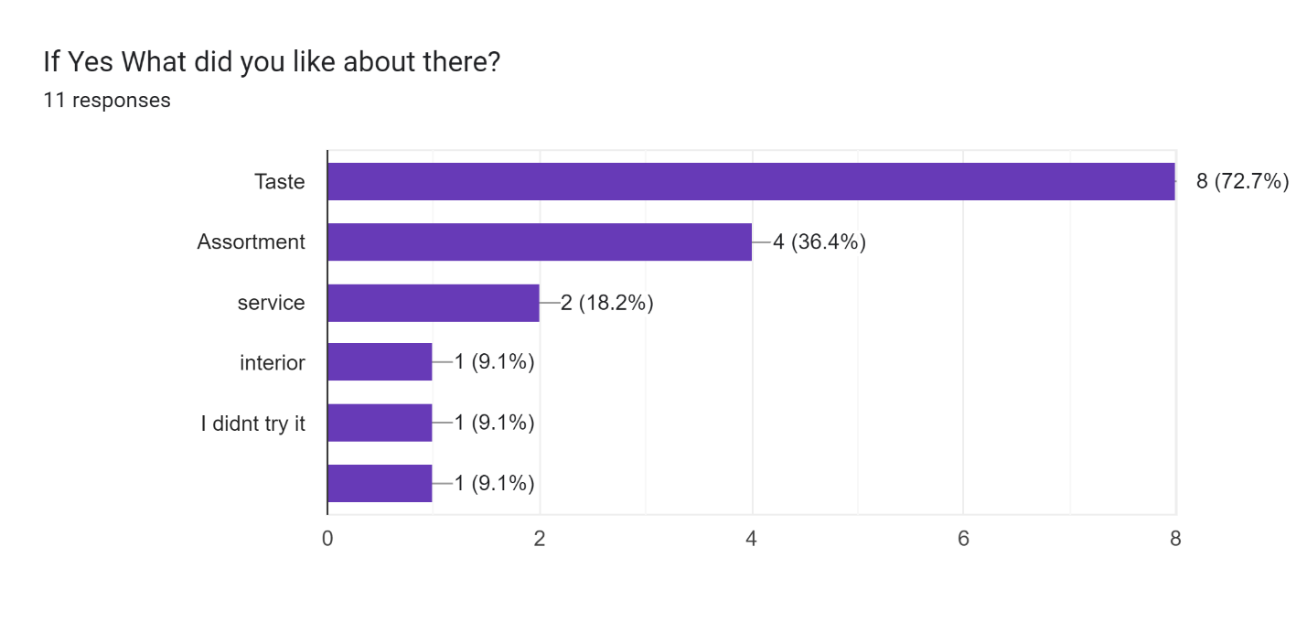

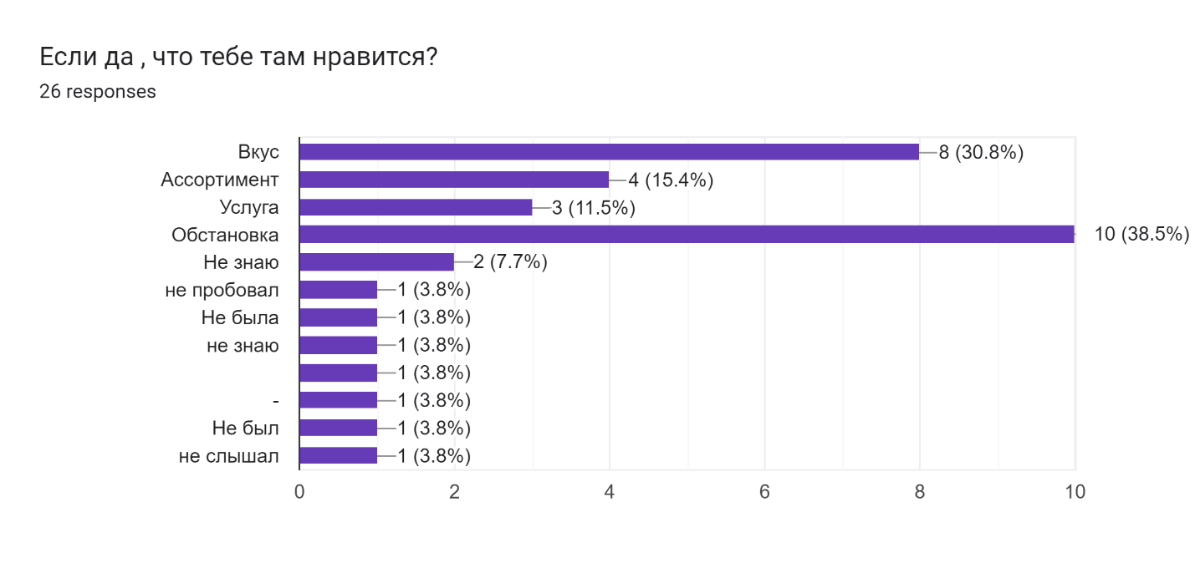

1. **What did you dislike about there? (Roma Pizza)**

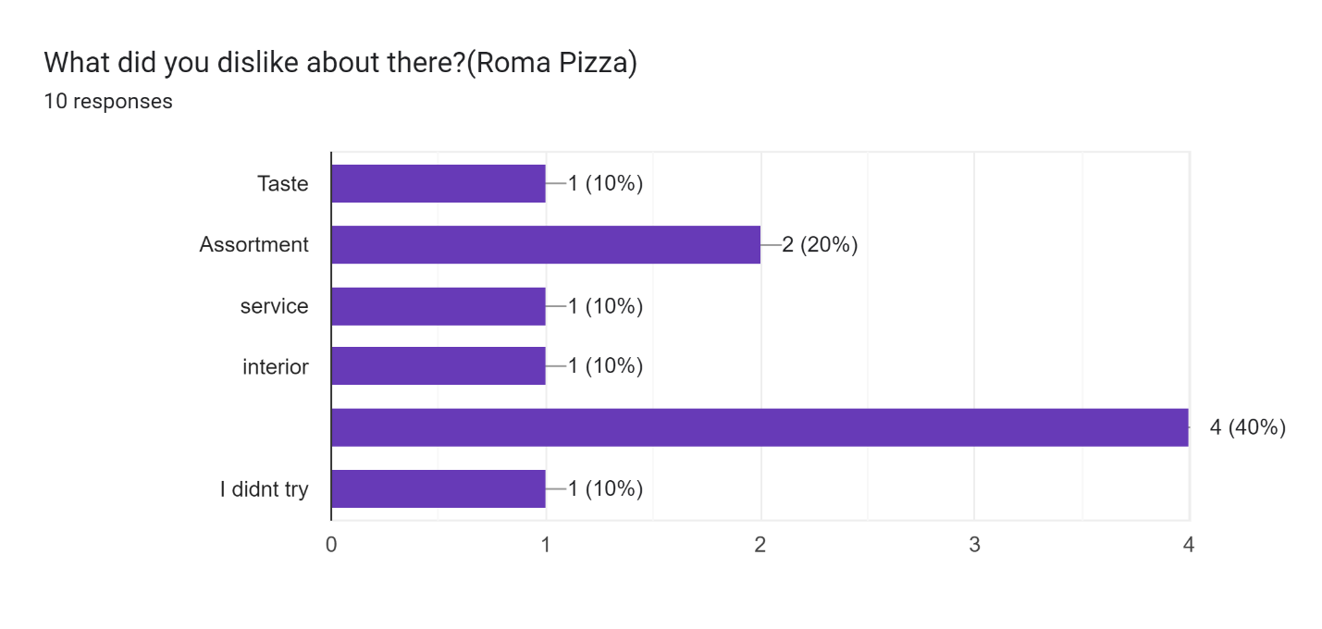

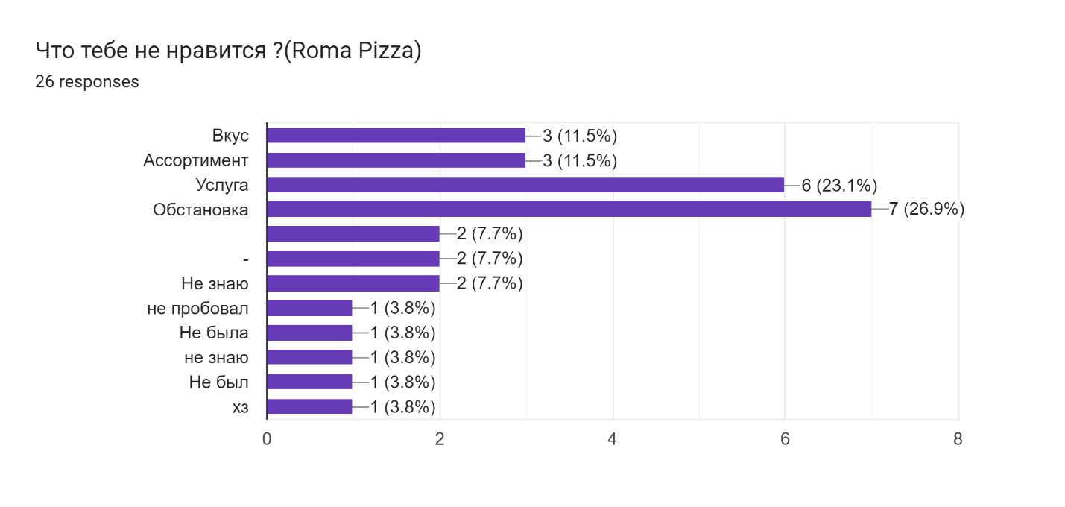

1. **Have you ever heard/been in there? (Little Italy New York style pizzeria.uz)**

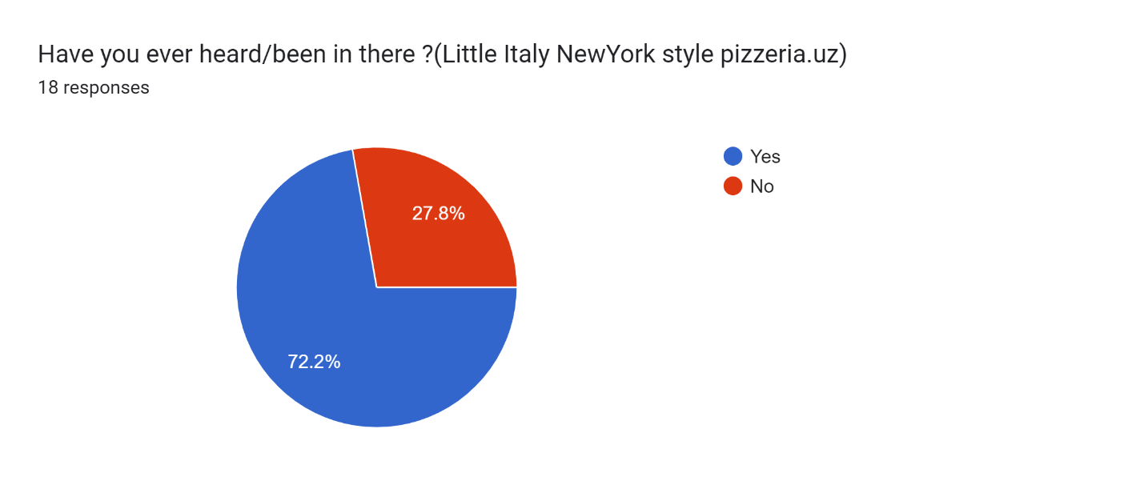

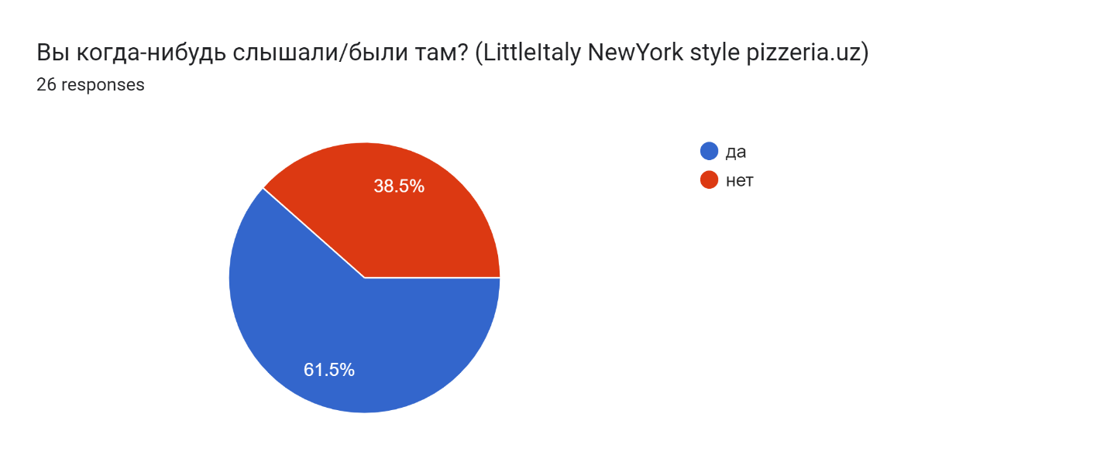

1. **How do you know about "LittleItaly"?**

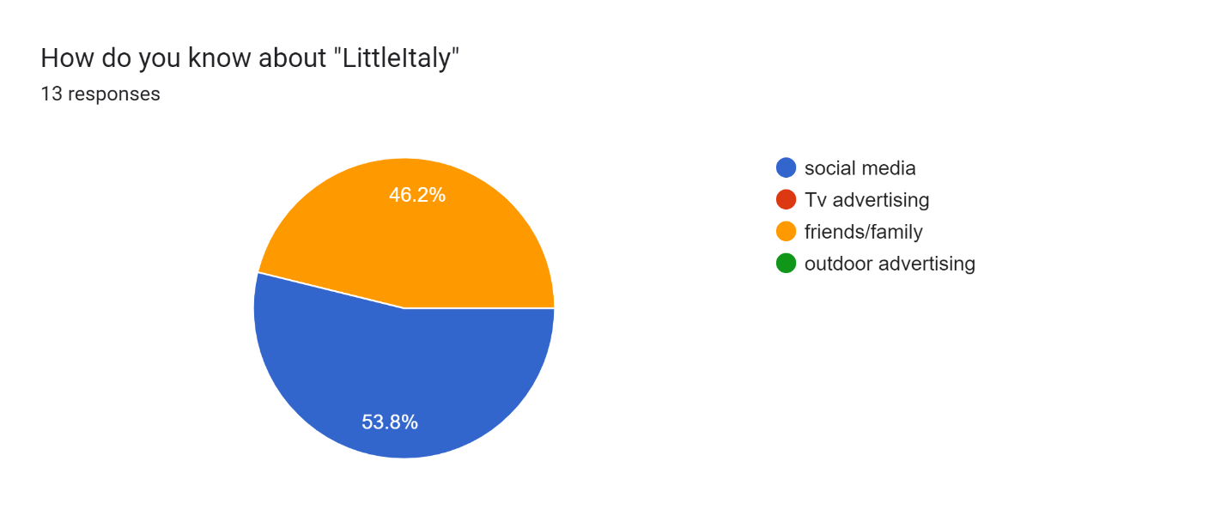

**Forms response chart. Question title: Откуда вы знаете о «Little Italy»?(pizzeria)
. Number of responses: 16 responses.**

1. **Could you tell us which factors do you like about this pizzeria?**

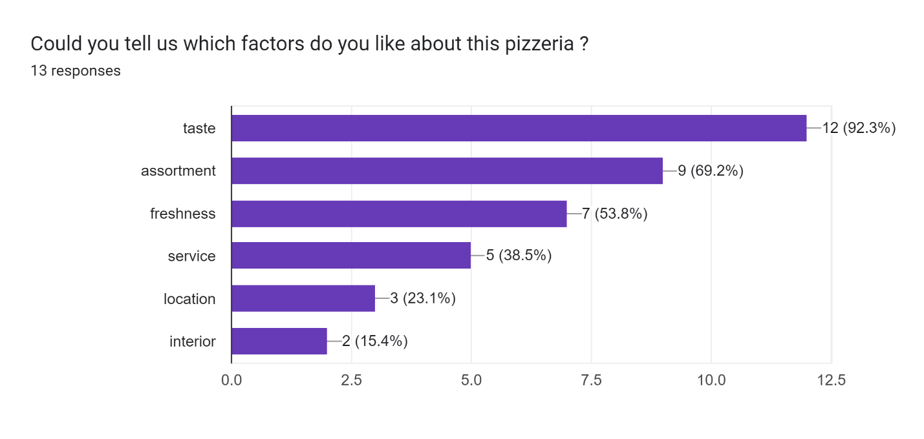

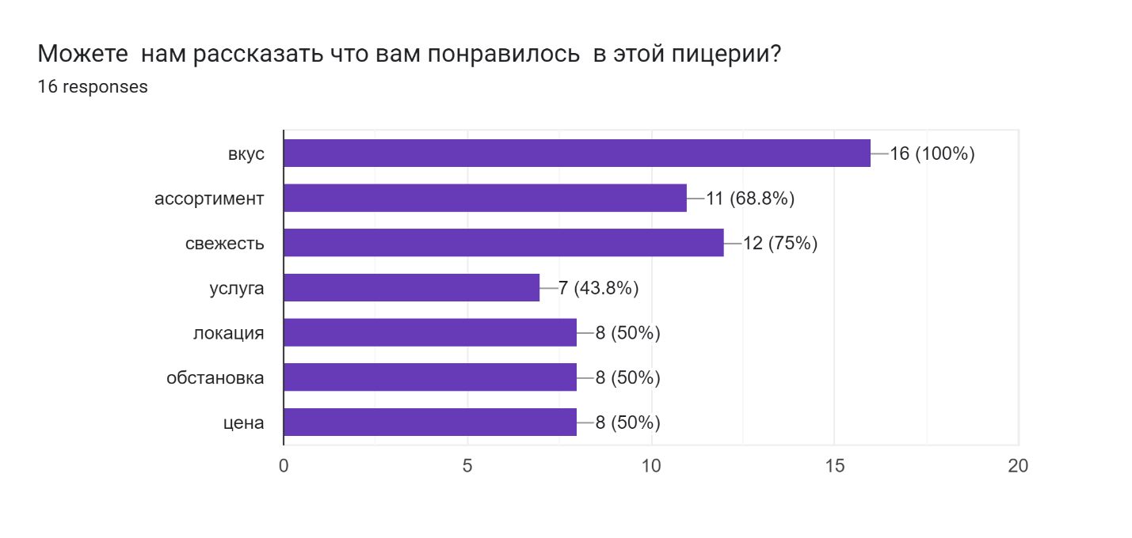

1. **How would you rate Price Policy of "Little Italy"?**

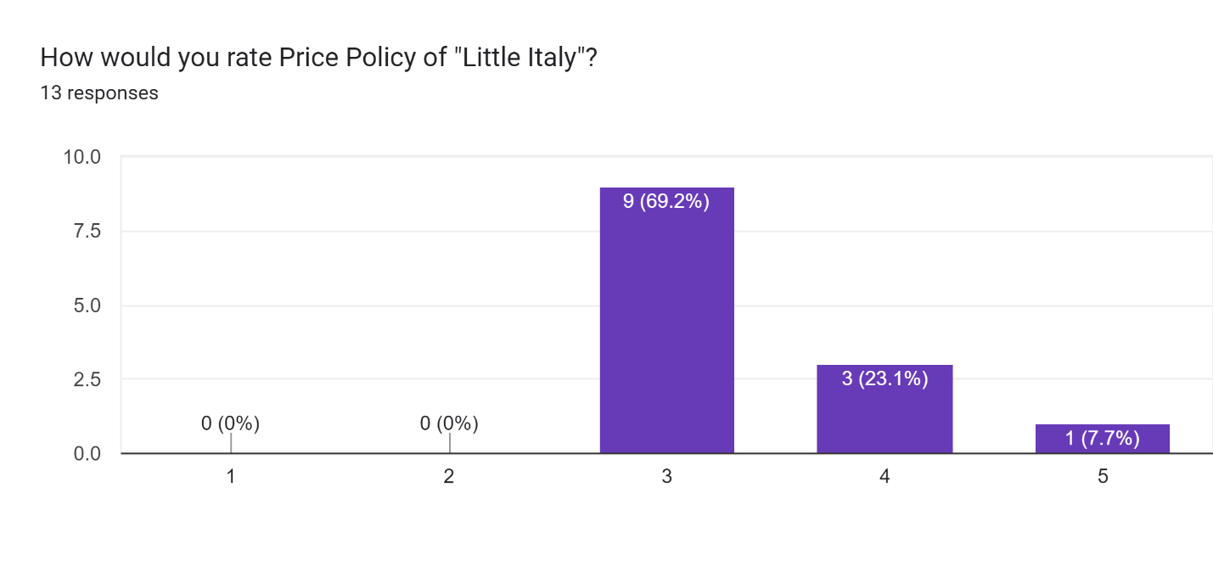

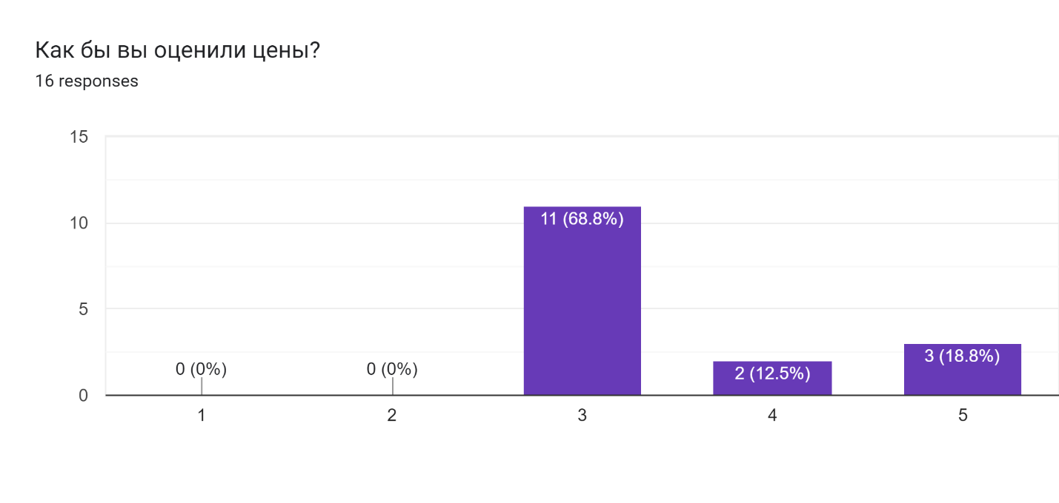

1. **In average, how much do you spend per person in there? (Little Italy)**

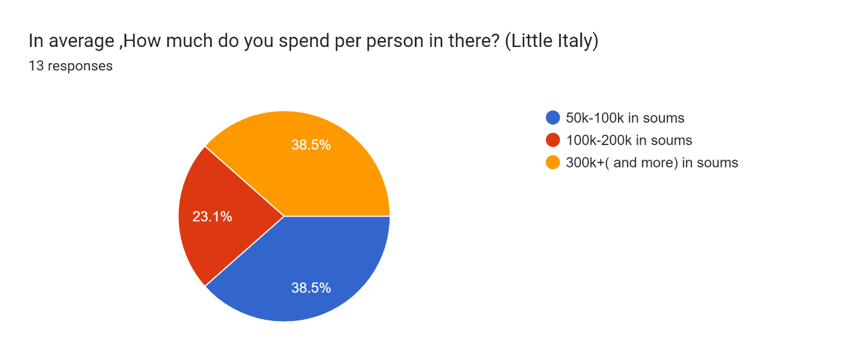

1. **Is there anything you would like improve or change?**

Но

Yes

No it's good

All the services, pizzas are really good

Maybe more branch

Nope

all good

Nothing

More locations

Нет

всё устраивает

Больше филиалов

Хорошо

Нет все хорошо

Обстановку

нет

Стулья бы изменил на обычные чем показано на рисунке потому что в них не удобно сидеть

Все хорошо

Net

1. **Is there any negative factors of the Pizzeria (LittleItaly) for you?**

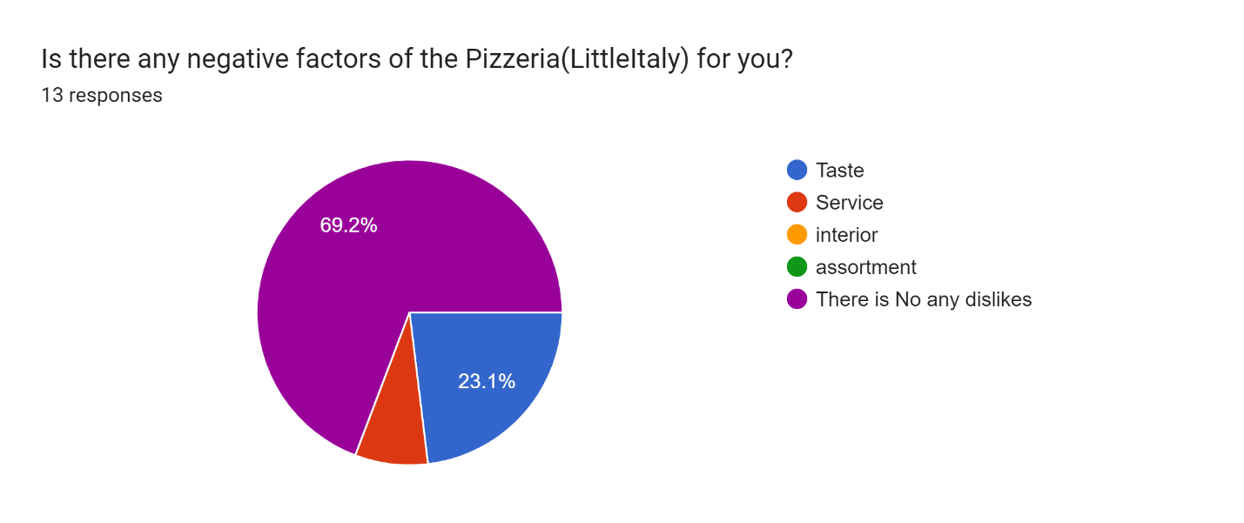

1. **How often do you go there?**

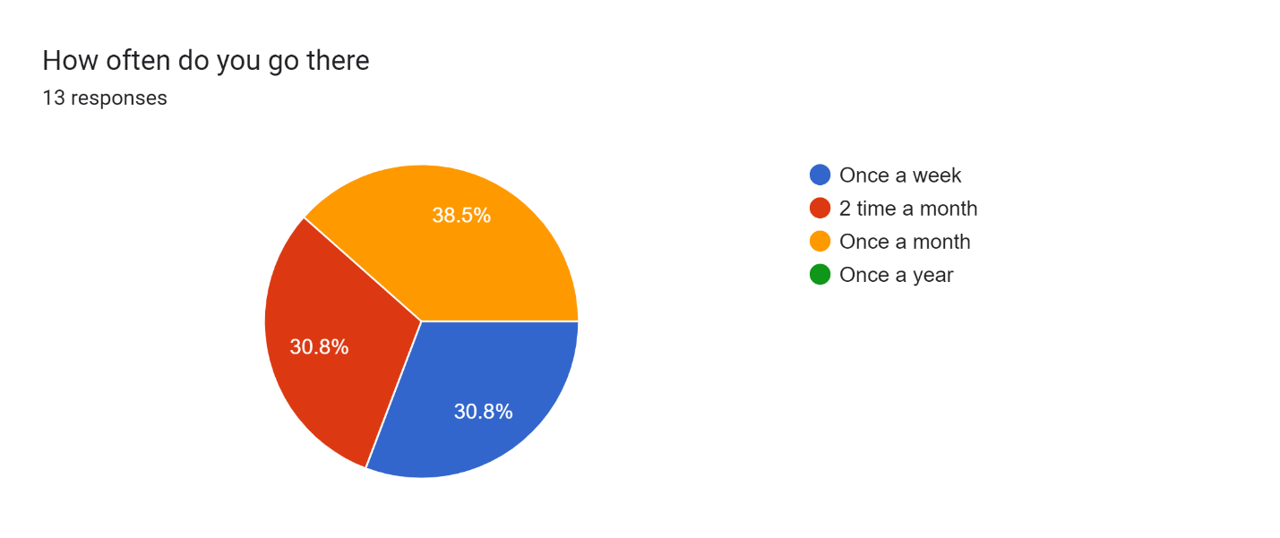

**Forms response chart. Question title: Как часто ты бываешь в этой пиццерии?
. Number of responses: 16 responses.**

1. **If No Where do you choose your pizza and why there?**

Bellissimo, cause it’s very tasty

Roma pizza

Bellissimo

-Bellissimo

-Dodo pizza

-Bellissimo

-Chopar, там вкусно

-В Bellissimo, из за вкуса

-Apex

-Bellissimo потому что там большой ассортимент и приемлемые цены

-Bellissimo потому нравится вкус пиццы

-Потому что я больше привык покупать пиццу в belissimo

вкусно

1. **Evaluate Belissimo Pizza according to following criteria?**

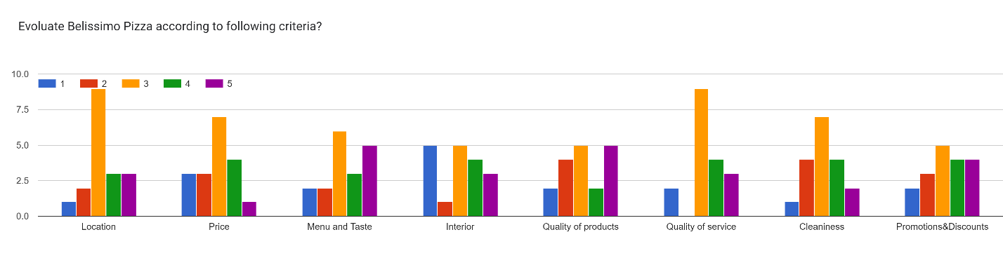

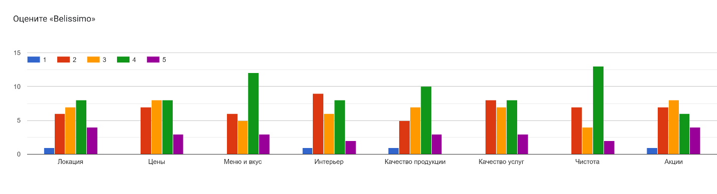

1. **Evaluate ApexPizza according to following criteria?**

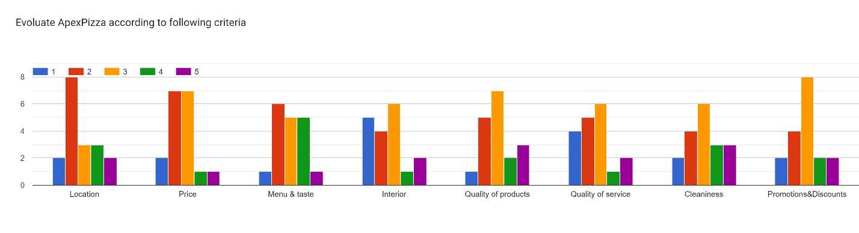

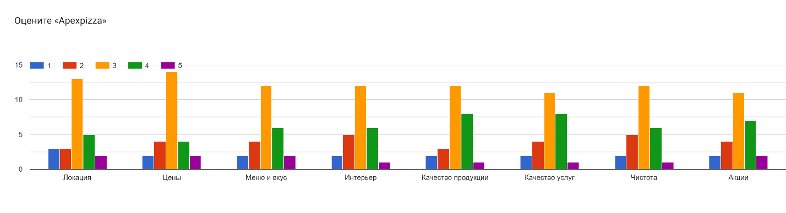

1. **Evaluate Roma Pizza according to Following criteria?**

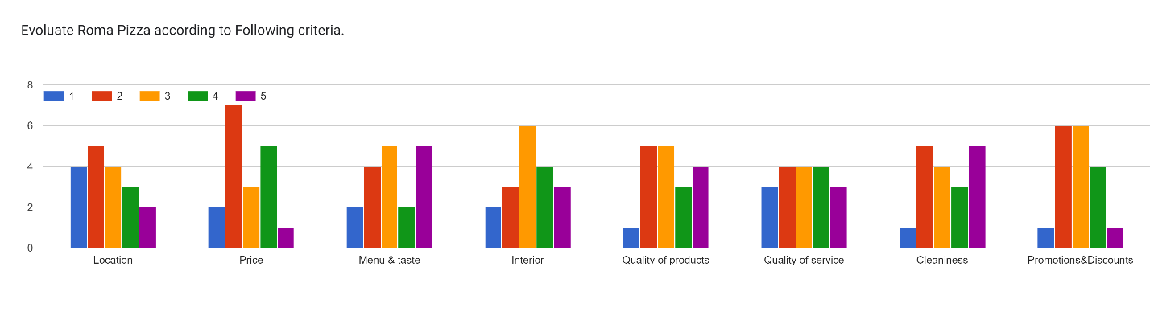

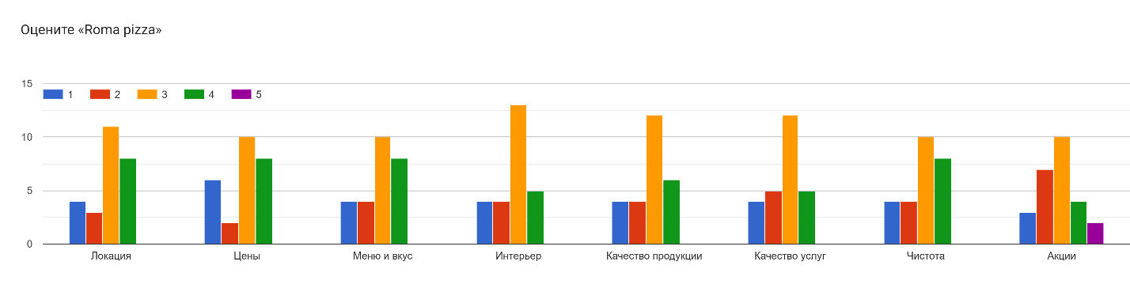

1. **Evaluate Little Italy According to Following Criteria?**

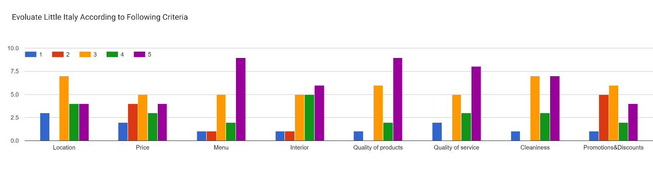

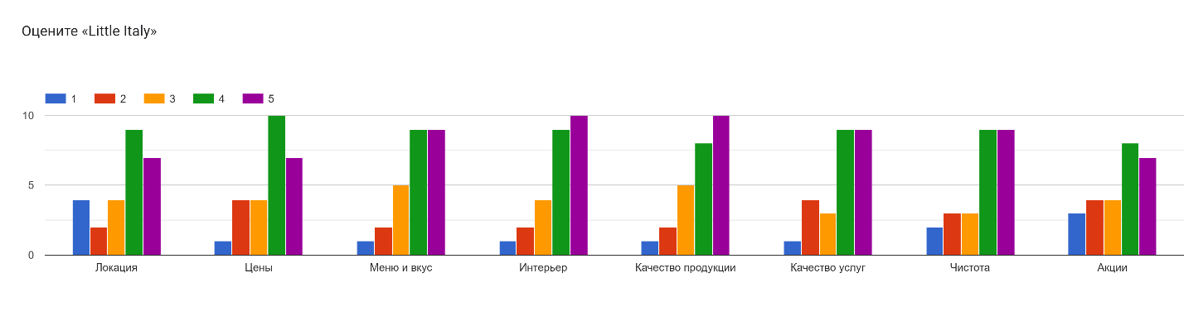

1. **What are your thoughts on the video?**

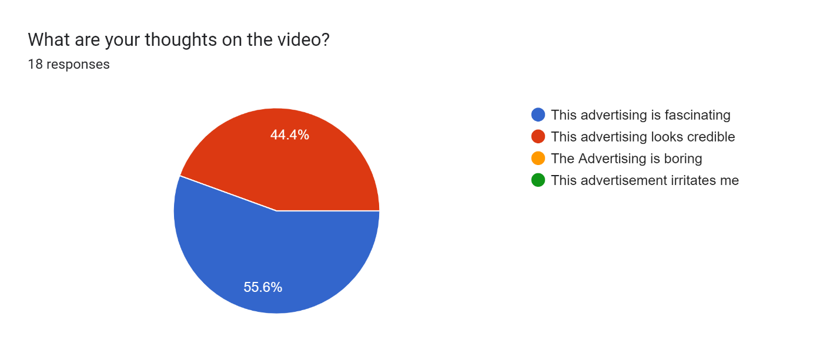

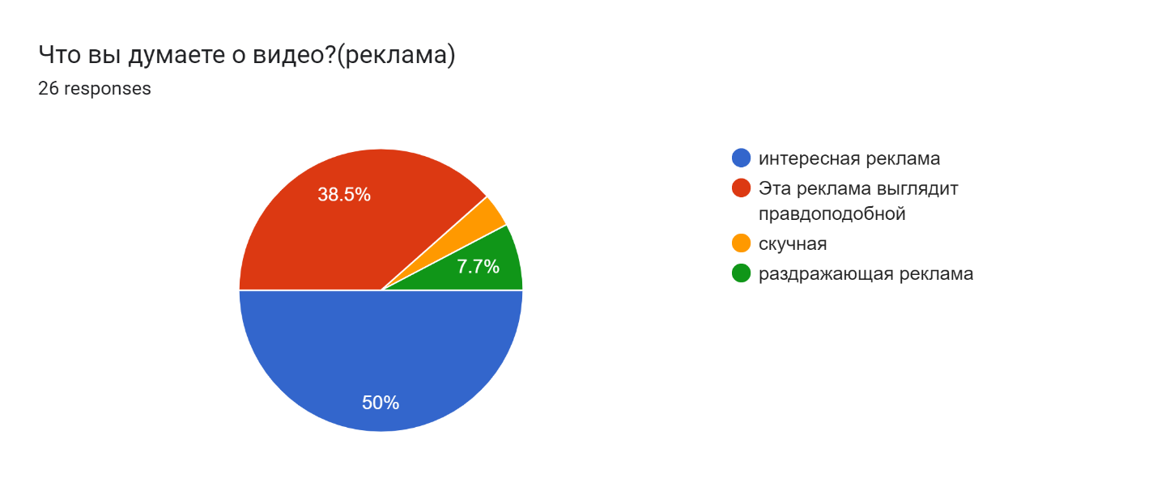

1. **What thoughts do you have after viewing the image below?**

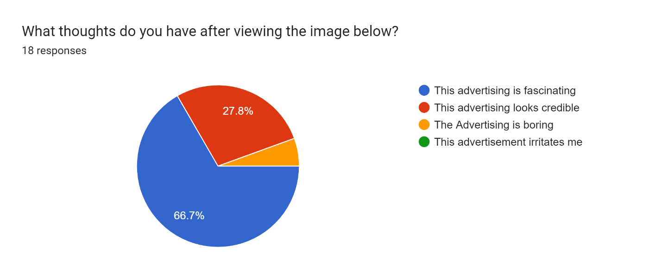

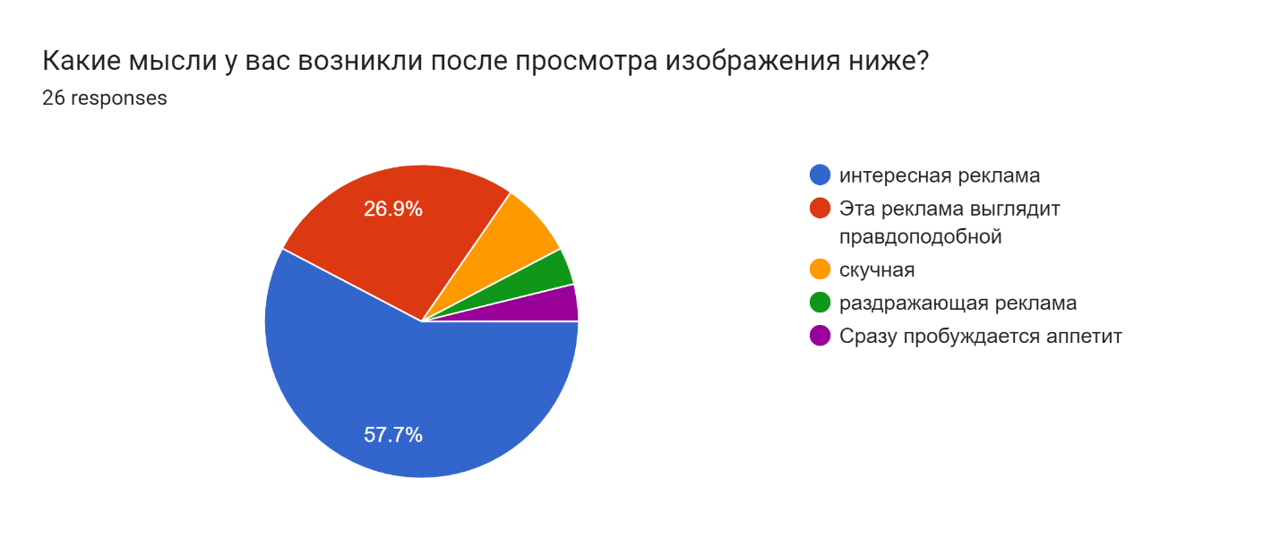

1. **Where do you live on (street, district)?**

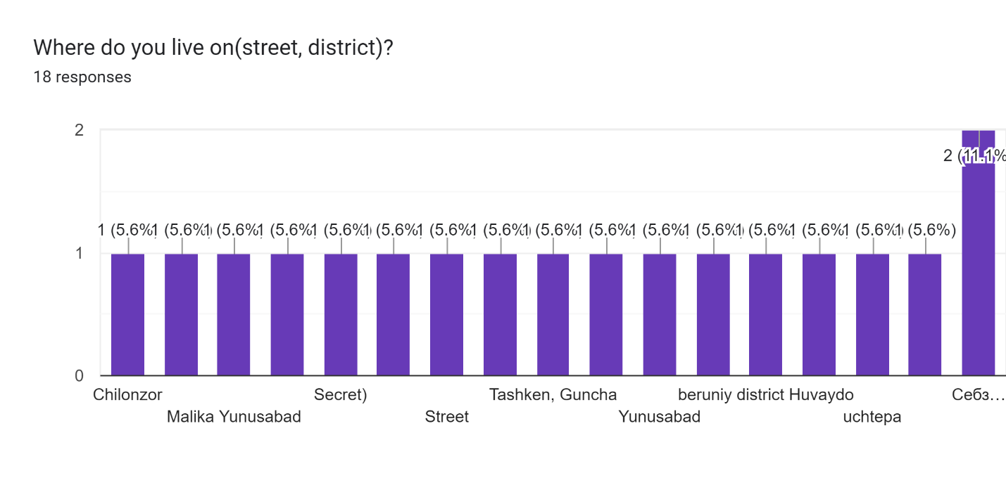

**Forms response chart. Question title: где вы проживаете?
. Number of responses: 25 responses.**

1. **What are your hobbies from the list below?**

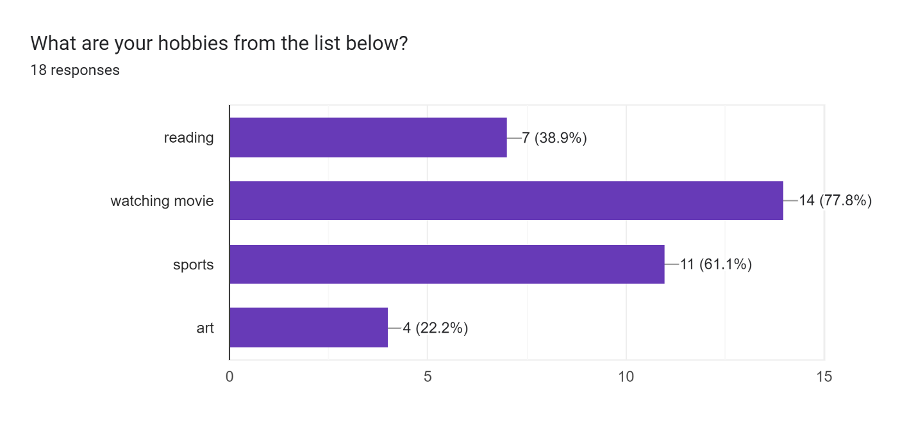

1. **What is your professional status?**

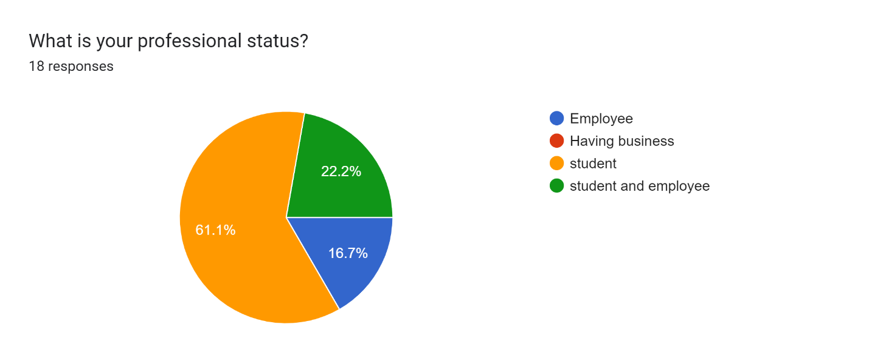

1. **What is your marital status?**

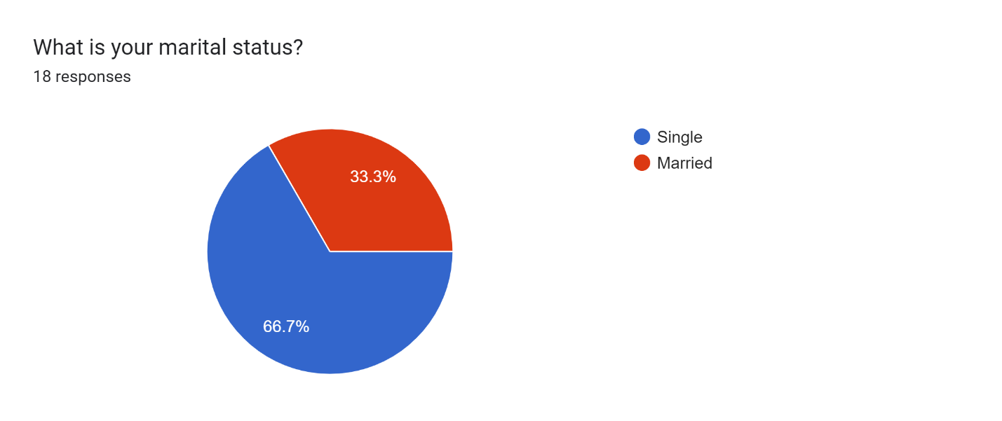

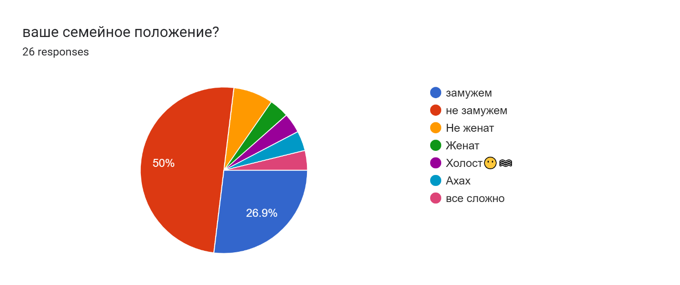

References:

Research

<https://docs.google.com/forms/d/e/1FAIpQLSfDcWUFGvXNUip8MZSbyr069rGZ38WRcVpAm9TOt5cLJISyTA/viewform?usp=sharing>

Ads:

<https://docs.google.com/forms/d/e/1FAIpQLSfDcWUFGvXNUip8MZSbyr069rGZ38WRcVpAm9TOt5cLJISyTA/viewform?usp=sharing>

<https://youtu.be/uOtCeMD9iBk?si=nDWWG_uqJGyng7mc>

<https://youtube.com/shorts/yCTycFvl2FI?si=VNixl4HnQtvn82fB>

Evidence

<https://youtu.be/VMS_lETLmNE?si=p3-7ZpoUWZ-In39h>

